**GIMNASIO LOS PIRINEOS**

**“EDUCACIÓN Y FORMACIÓN INTEGRAL CON ENFASIS EN VALORES, INGLÉS, EMPRENDIMIENTO Y GESTIÓN LABORAL”.**

**EVALUACION PERIODICA ACUMULATIVA**

**INGLÉS- GRADO OCTAVO**

ESTUDIANTE: __________________________________ FECHA: __________________

Write the names of the food and drink in the boxes below the picture.

**Pizza steak hamburger fish cappuccino fruit smoothie English breakfast pasta**

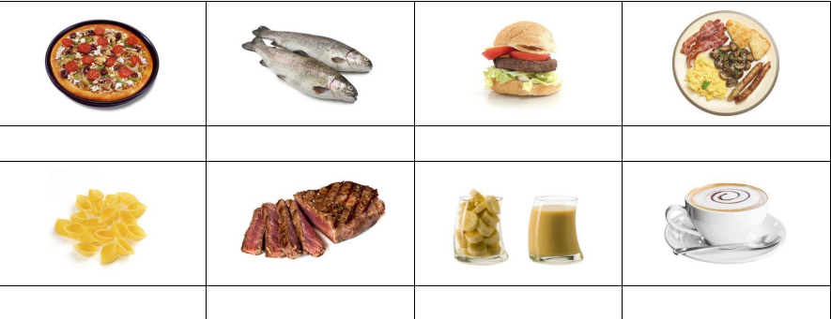

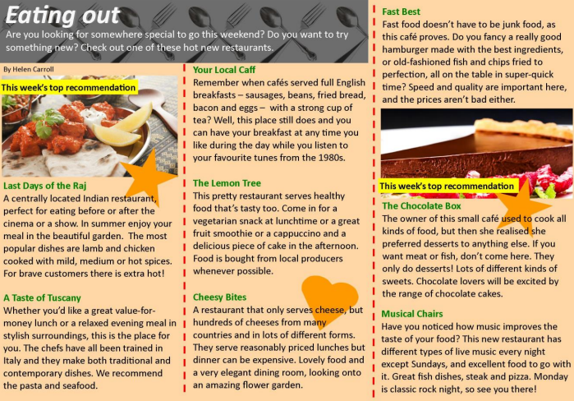Read the text.

Match the people with the best restaurant for them. Write the restaurant names below

**Your Local Caff The Lemon Tree Fast Best The Chocolate Box Last Days of the Raj A Taste of Tuscany**

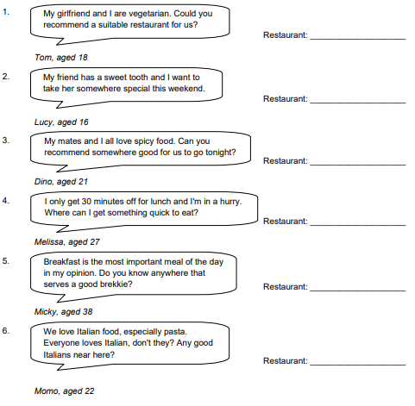

Write the names of restaurants from the article

1. Which restaurant(s) serve hot and spicy food?________________

2. Which restaurant(s) only have desserts and sweets?______________________

3. In which restaurant(s) can you listen to some great music?____________________________

4. Which restaurant(s) are good for people who

don't eat meat?_________________________

5. Which restaurant(s) employ staff trained in

Europe?________________________

6. Which restaurant(s) serve an all-day breakfast

including sausages, bacon and eggs? ______________________________

**Grammar**

Fill in the blanks with “some” and “any”.

1. There isn’t ………… eggs left at home.
2. I would like to have ………… cookies.
3. Pour ………… milk on the cereals.
4. Is there ………… milk for my cat?
5. You must buy ………… vegetables.
6. I don’t need ………… drinks now.
7. My father wants ………… cream with his coffee.
8. Jim wants to have ………… water.
9. Do you need ………… rice with chicken?

**10.**I don’t have ………… walnuts.

Fill in the blanks with “is” or “are”.

1. There ……… a cat under the sofa.
2. ……… there any apples in the fridge?
3. There ……… two cars in front of our house.
4. There ……… no water in the jug.
5. ……… there any eggs in the pie?
6. There ……… some milk for our cat.
7. There ……… no songs in my mobile phone.
8. There ……… a vase on the table.